From Shared History to Shared Hope
A Living Sky Treaty Education project with Dance Sask.

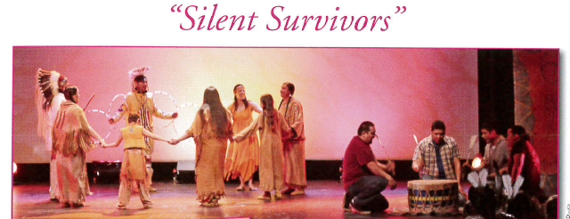

What is our shared history regarding Residential Schools in Canada?

How will the Arts build better understanding of this complex story?

How can we build hope for the future as we share our stories?
Location: Don Ross, North Battleford
Dates: book your day - Tuesday, Oct 7th to Friday, Oct 10th, 2014
Target Audience: grade 5 – 12
Cost: Free program
School pays for bussing, bring a bag lunch
Time: 10:00am – 2:00pm

The day will include elder teachings, discussion, live performance of “Silent Survivors” dance/theatrical production and a workshop with an artist/performer/cultural leader.

Teacher support material for both introduction and follow up on residential school topics will be provided prior to the program. If interested, classes will be invited to participate in an art making and creative writing celebration to share with the division as a follow up project and tour of student art and writing.

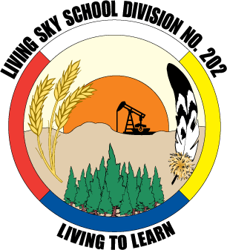
Book soon – email Sherron Burns at sherron.burns@lskysd.ca.
Thank you to our partners: Elders, Dance Sask Inc., Allen Sapp Gallery, and Sunchild Law.

