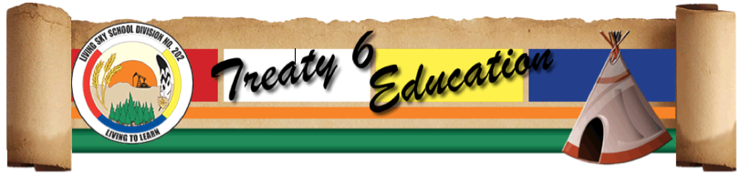

Living Histories in Living Sky School Division

Request for Visit and/or Project Proposals

Please use this form to indicate a request for a visit from a First Nations or Métis artist, elder or cultural leader (single day) and/or longer project for your school. Submit to Sherron Burns, Learning Consultant, LSKY by email sherron.burns@lskysd.ca or by fax 445-4332. Please apply at least 2 weeks prior to the event.

School: _______________________________________________________________________________________

Teacher/Staff Contact: ____________________________________________________________________

Grade(s): _____________________________ Subject(s): ________________________________________

Preferred Date(s) of Visit and/or Project: _______________________________________________

Guest Artist, Elder or Cultural Leader:
(if you don’t know the name of the preferred guest, describe what type of skills or knowledge you are looking for as a resource)

________________________________________________________________________________________________

________________________________________________________________________________________________

Summary: Please attach:
- purpose of the visit and/or project
- proposed guest schedule
- connections to the curriculum
- benefits to the students and the school
Schools can use our Cultural Directory to find their guest or might work with Sherron Burns or Michelle Sanderson for help. Cost of the program may be split 50/50 between the division and the school. Protocols will be followed for working with elders.

